**TEACHABLE MACHINE GOOGLE**

1) SAD AND SMILE

THIS MODEL IS USED TO CHECK IMAGE DETECTION ON SMILING FACE OR SAD FACE.

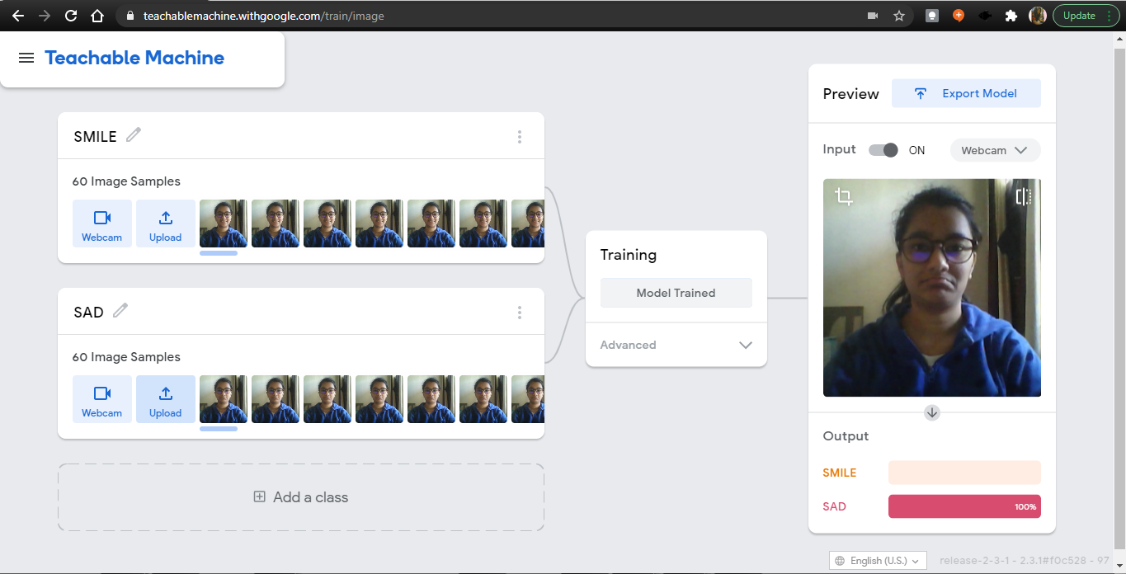

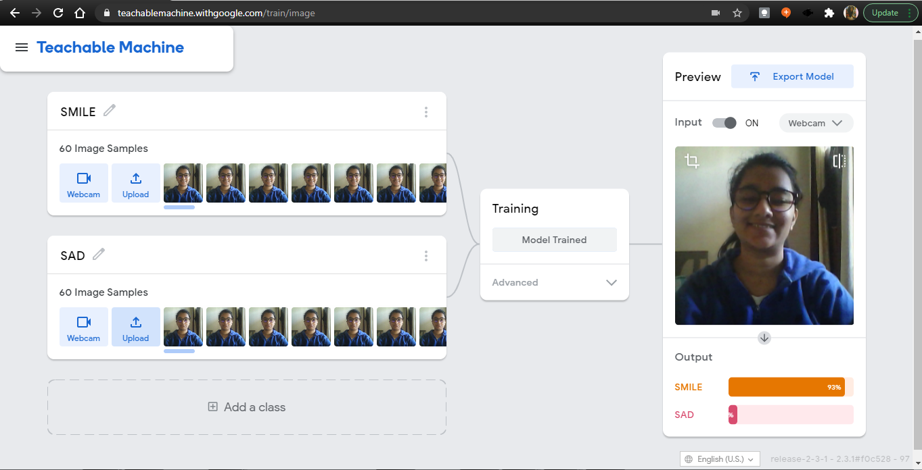

2)HEALTHY AND JUNK FOOD

THIS MODEL WILL DETECT THE IMAGE OF THE VARIOUS FOOD ITEMS AND WILL TELL YOU THAT THE FOOD YOU ARE CONSUMING IS HEALTHY OR JUNK FOOD.

